Setting Up Application Environment

CREATE IBM CLOUD ACCOUNT

**Team ID: PNT2022TMID20238**

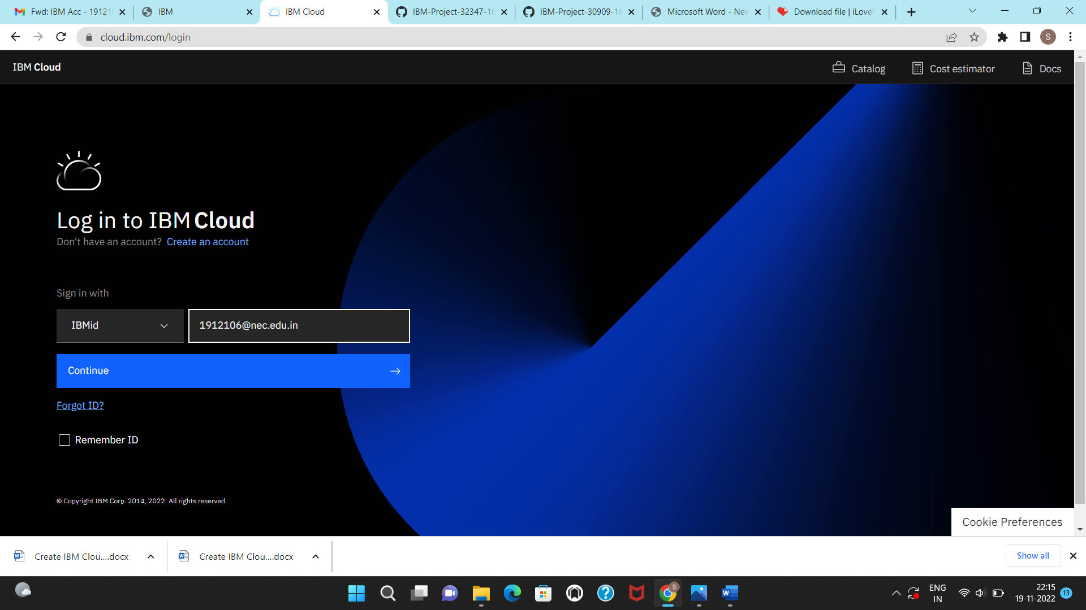

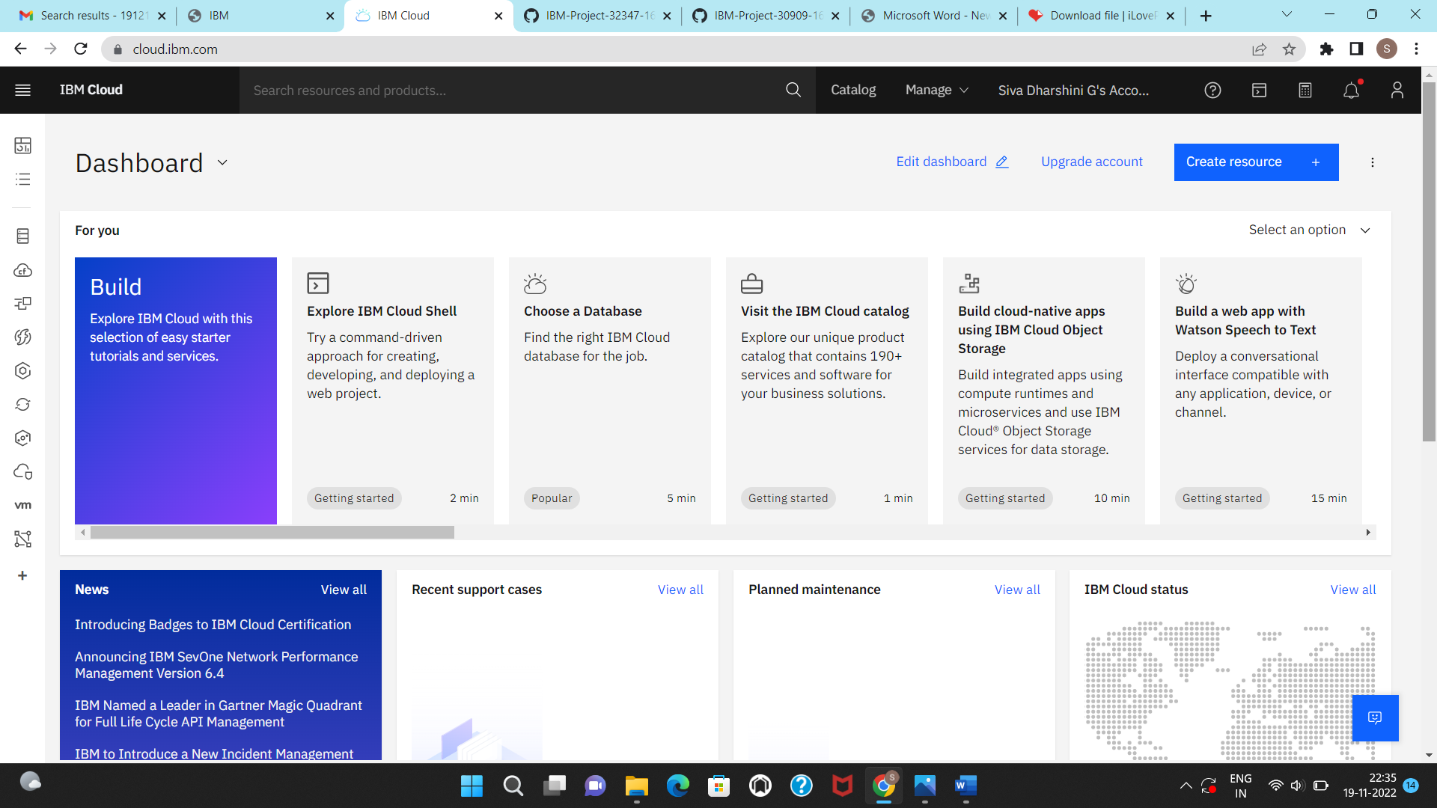

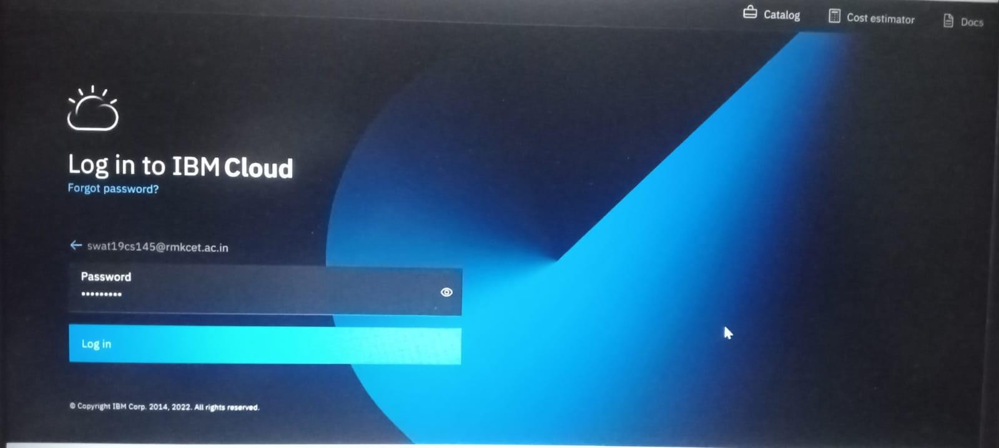TEAM MEMBER: SWATHI.N(111619104151)

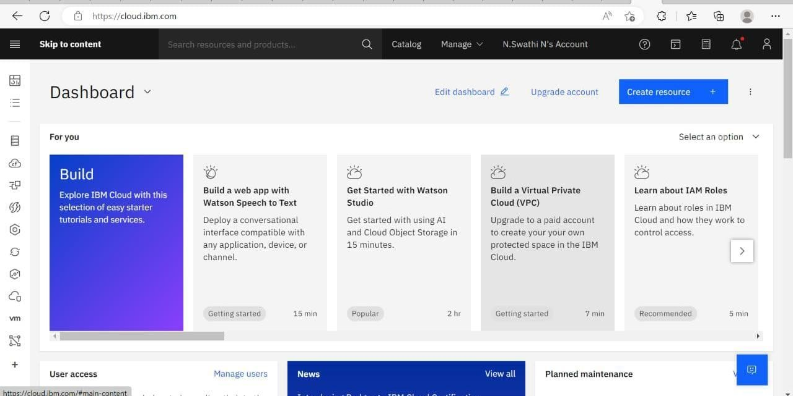

TEAM MEMBER: SHAMITHA R V(111619104137)

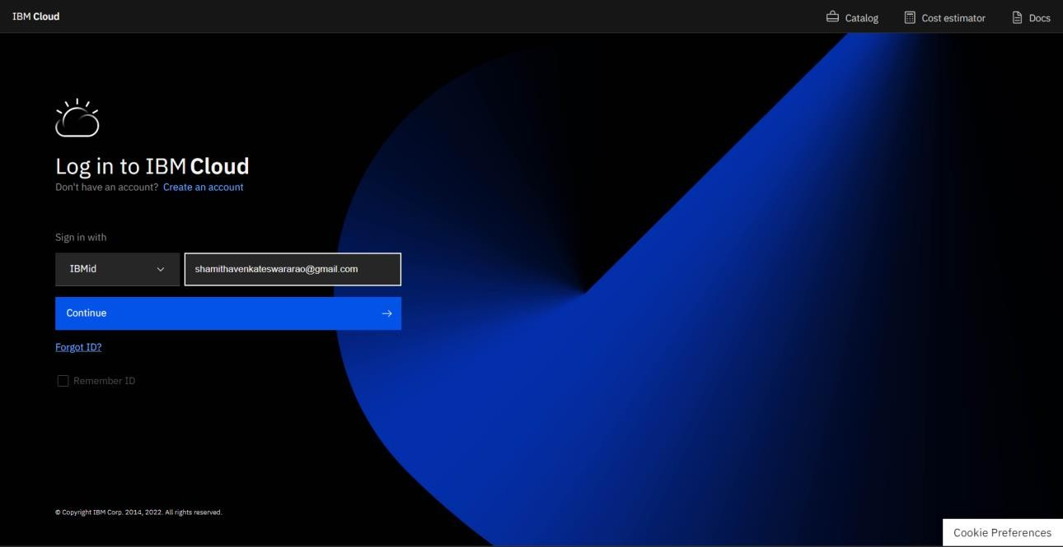

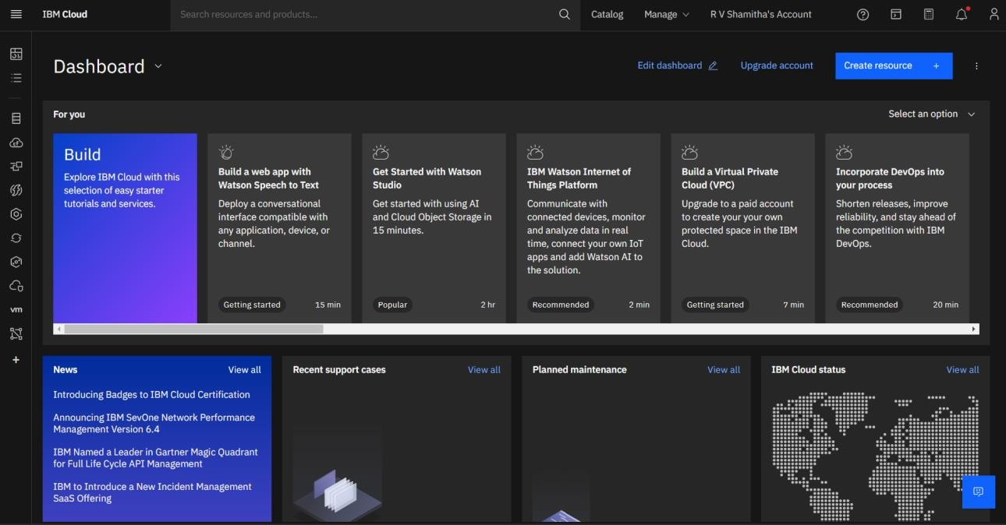

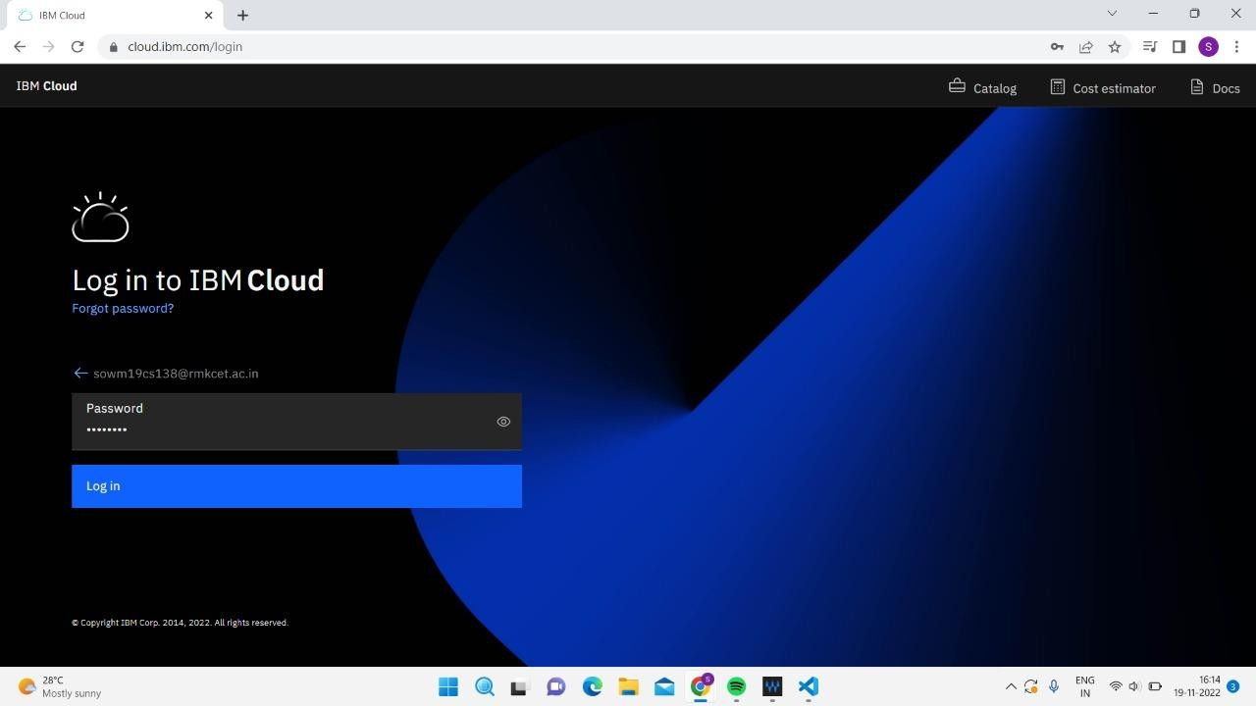TEAM LEADER: SOWMYA P(111619104143)

